: How to Administrate GitLab:

We are using gitlab to manage our GIT repository. In gitlab you can add/delete users, add/ delete projects, assign/ unassigned users to projects.

- How to create a User:

Login to the Gitlab server with Admin credentials. URL: http://git.andolasoft.co.in
After login you can see the dashboard.

Click on the “Admin area”.

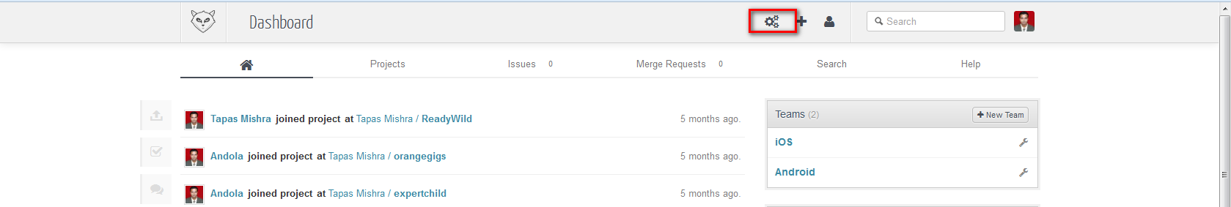

Click on “New User”

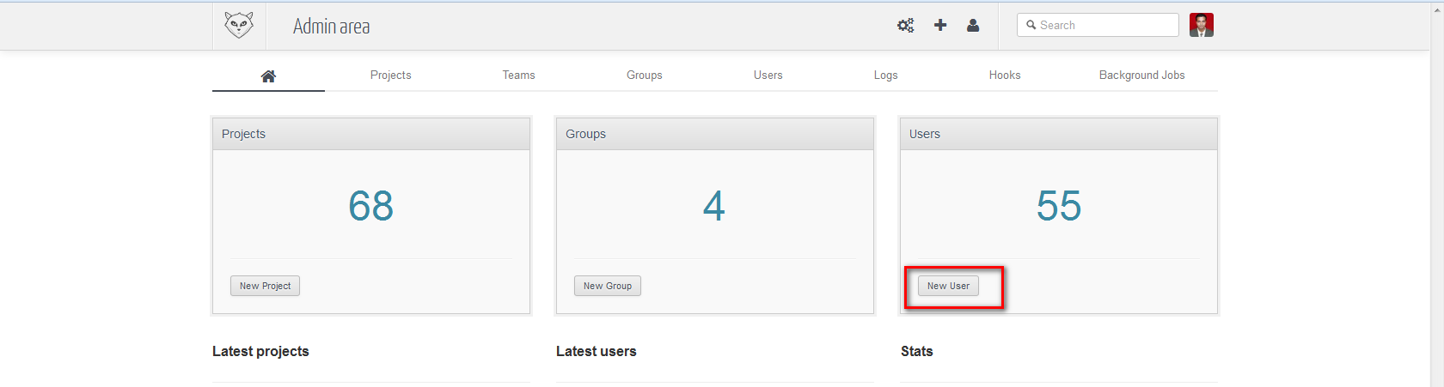
Enter Name, Username and valid Emai address of the user. Enter the password if you want to set the user’s password unless check the “Generate random password” filed. It will generate and send an email to the user. In Access Field set project limit. Check the “Administator” if you want him as a administrator. Then click on “Save”.

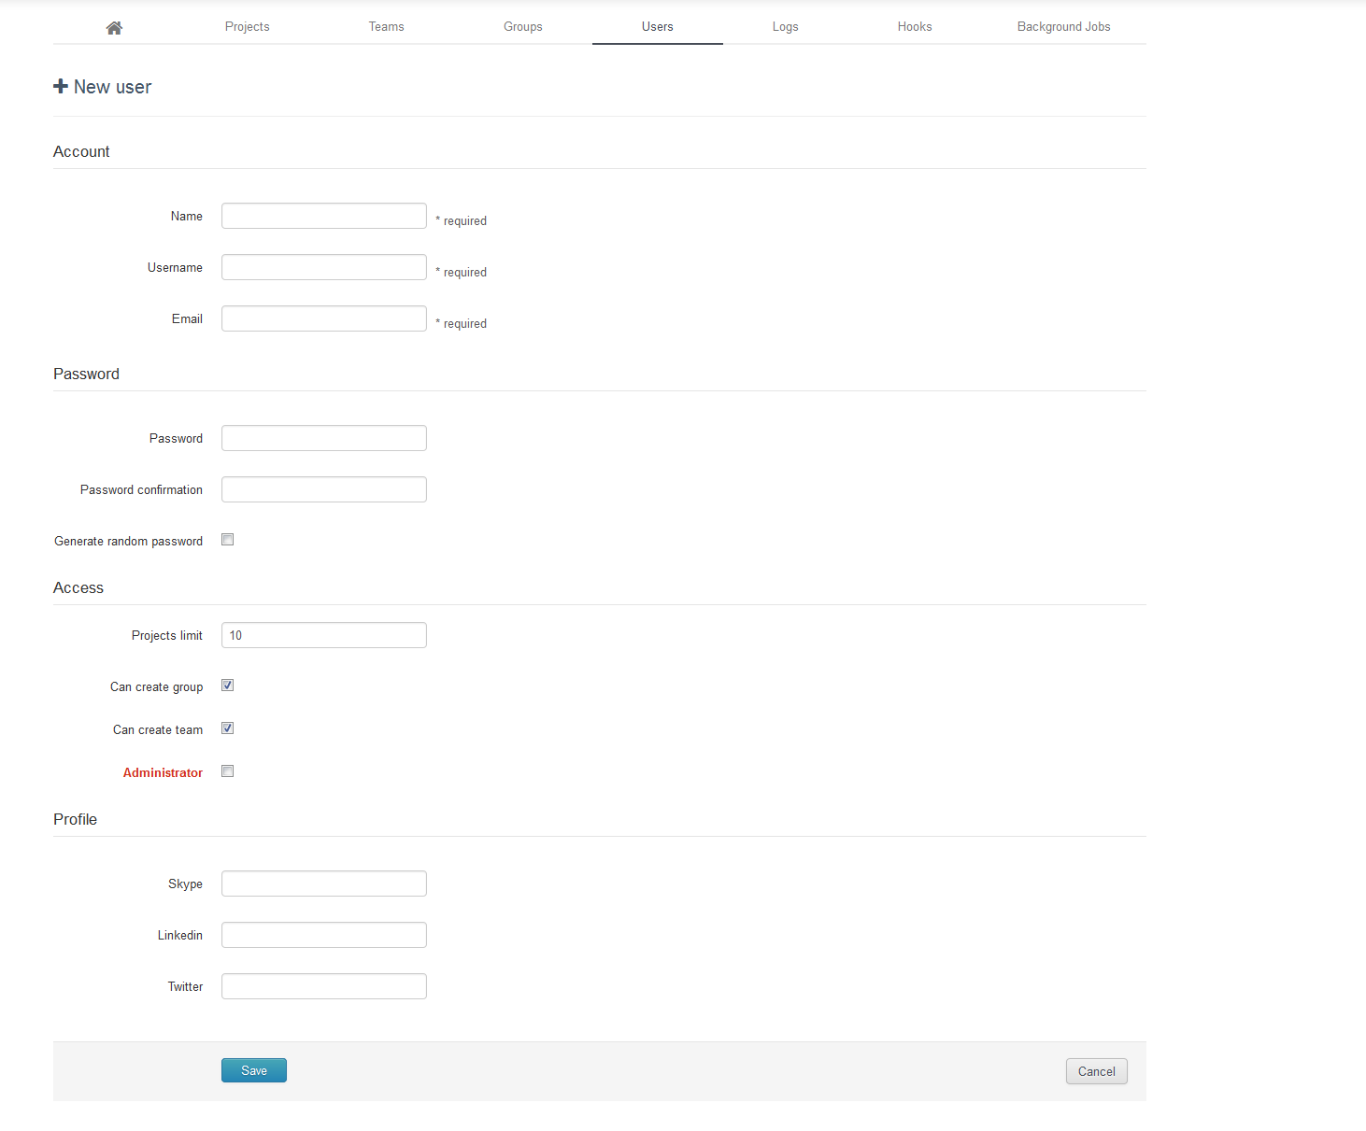

- How to create projects.

We are managing all the projects from a user account instead of an administrator account.
After login to the account you can see the below dashboard.

Click on the “+” on the top of the dashboard or click on “+New Project” to create a new project.

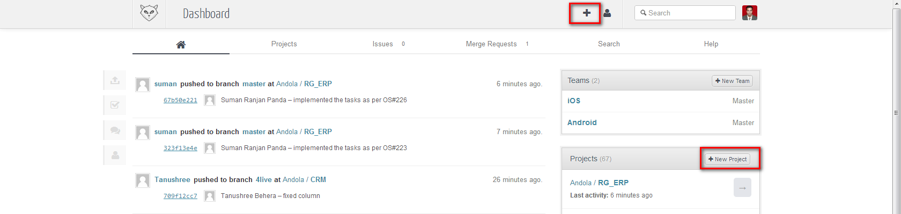
Enter the Project Name and press on “Create Project”
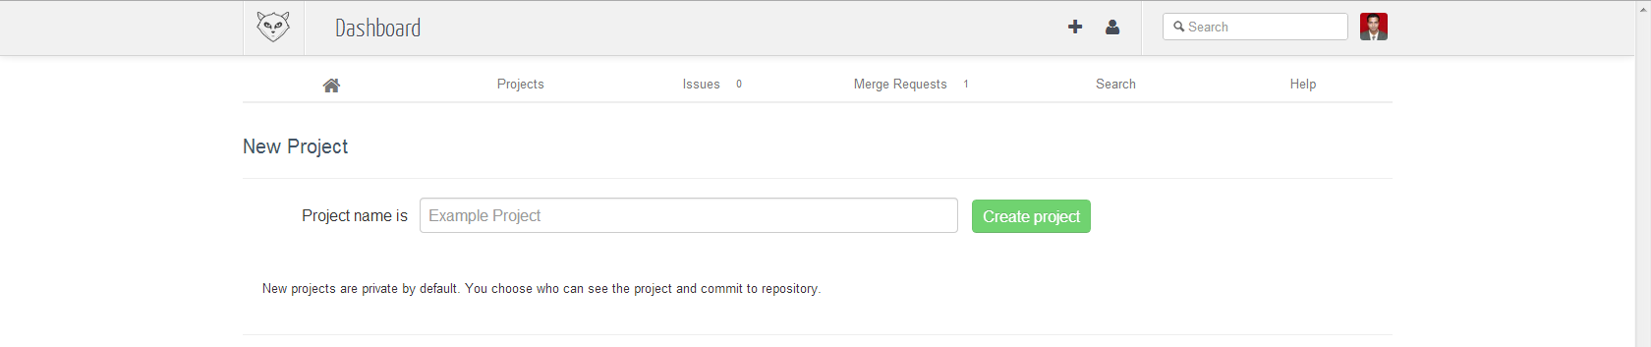
- How to assign user to a project.

Click on the specific project to which you want to add user. Here I am giving an example of “RG_ERP”.

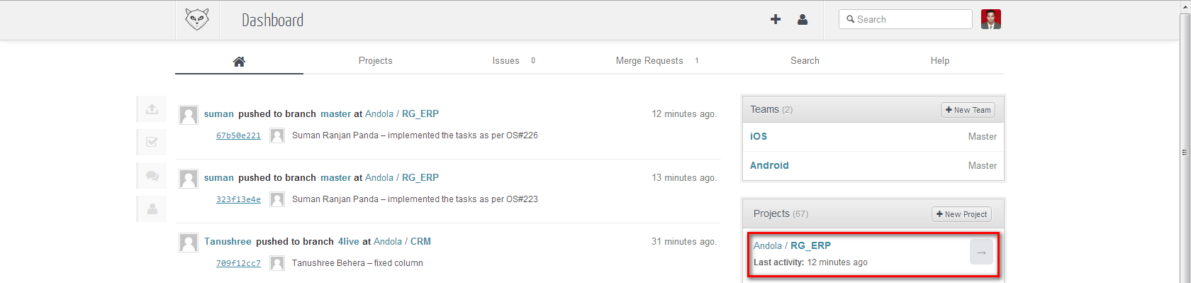

Click on “Team” tab.

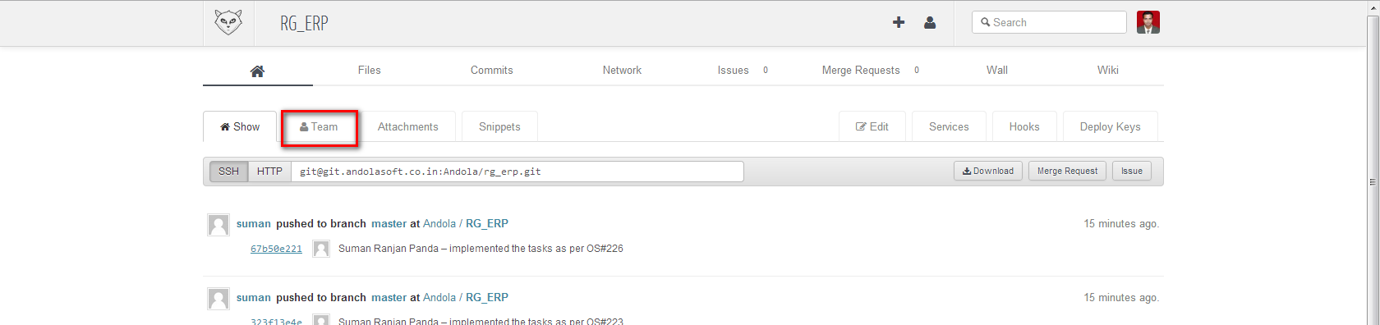

Click on “New Team Member”
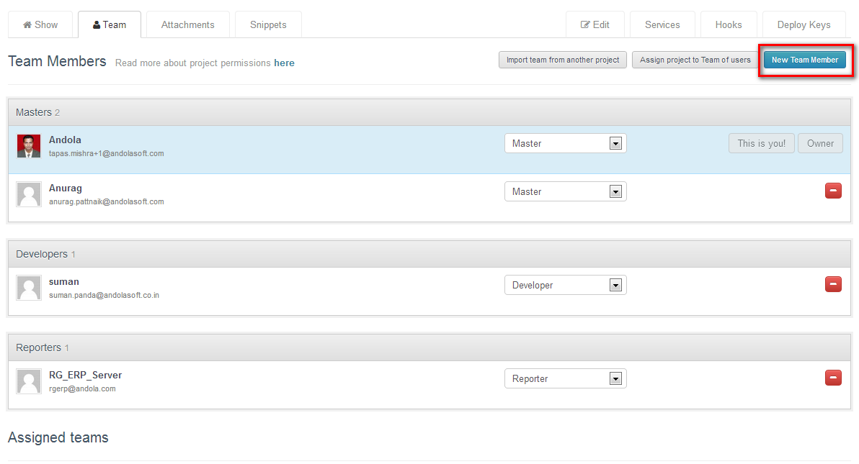

Select a member name

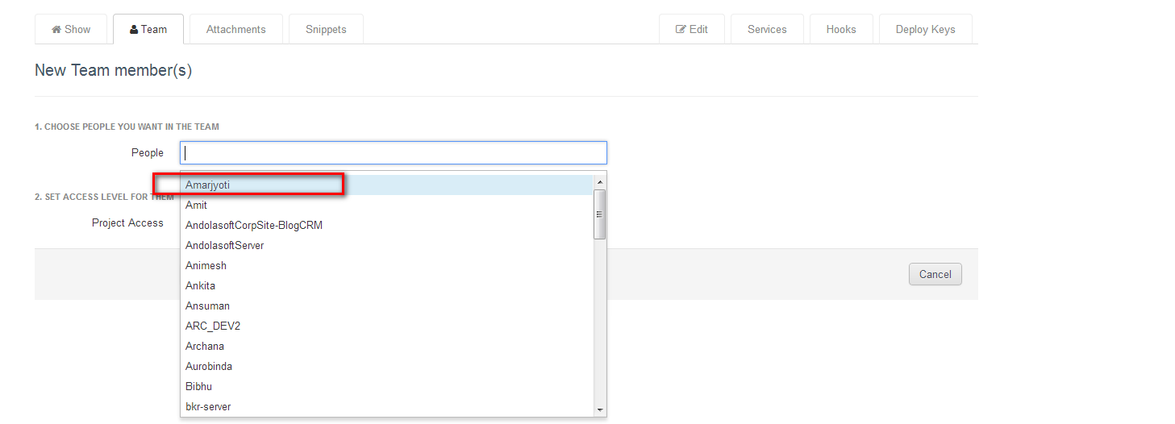
Select appropriate Project Access level and click on “Add users”.

